**Environment Setup and Running**

**Tools used to build the website**

* To start designing the website, the team made use of an IDE that would create it. We made use of Visual Studio Code, to design the html structure, the CSS decorations and animations, as well as the javascript interaction of the website.
* Apart from the tools on the laptop, we also designed a rough website idea on paper, which would greatly influence how the website would look, as we moved forward.

**Explanation of how these tools are integrated**

* The first step in creating our website, was agreeing on the basic appearance. Once the basic blueprint was decided on paper, it was time to implement it using code.
* With regards to Visual Studio Code, it has many extensions, that made creating our website possible. We combined the html, CSS and javascript together, by using the html, as the content storer of the website. We then added CSS and javascript to the html, using html’s inbuilt function. Customizing the html content, using the CSS and javascript, was made easier, by putting the CSS and javascript into their own external files.
* Once all the codes were functioning well, we made use of Visual Studio Code’s previewer extension. Once we saw how our code would make our website look on a browser, we used the open-in-browser extension, to open it on an actual browser.

**Web app is running on all browsers**

* Our website can open and function on all the web browsers, such as Chrome, FireFox and Microsoft Edge.

Project Narrative:

The gender based violence safe space website is a site aimed at providing information about GBV, from anyone who wants to know more about it in order to support a friend or family member, to a victim or perpetrator who needs help in making a change in their lives.

The Home page of our website serves as an introduction to what gender based violence is. The homepage includes a navigation bar where the users are provided with helplines, our contact details, the sign in and the about us, to tell people who we are and what our website provides. It also includes a short definition of gender based violence, an awareness video, stories of survivors of GBV, which all are meant to draw the users attention in wanting to learn more about the subject and for other survivors to be encouraged to share their stories on how they overcame this tragic experience so that it can help a current victim deal with their problem easier. In order for them to learn more, there is a button provided for them that they can click whereby it will direct them to the body of our website, which provides a more elaborate explanation of what GBV is and all the other important information one needs to know about it. At the end of the homepage, there is an upload story section for those survivors who are willing to share their stories and help a victim as well as our social media sites which will contain all these stories, anonymously, some words of encouragement and helplines.

To conclude our website, there is a section for victims, in the body, which explains what a victim is and all the effects GBV has on them, so that victims can be aware of their problem and want to take the step of making a change in their lives.

So once the victims has read their sections, there will be a link that will direct them to the login section of our website. The idea of the login section is to provide the victims with necessary information, once logged in, so that they can use it to help themselves as we aim to help them help themselves, as well as provide words of encouragement that will eventually make them want to get professional help. This serves to just give the emotional support and hope to help them take that first step for their healing process.

Web Layout Mockup:

Home Page:

Navigation bar and slideshow

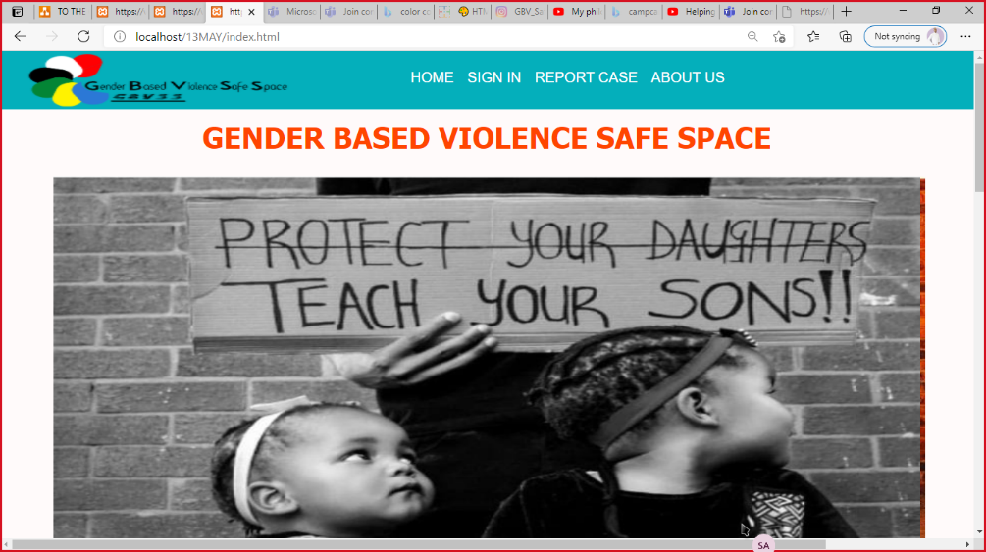 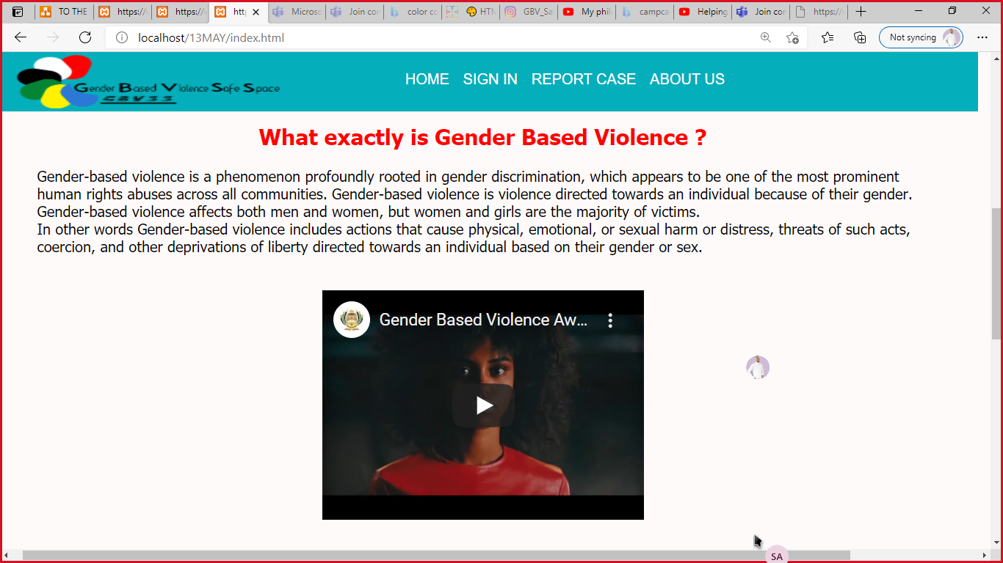

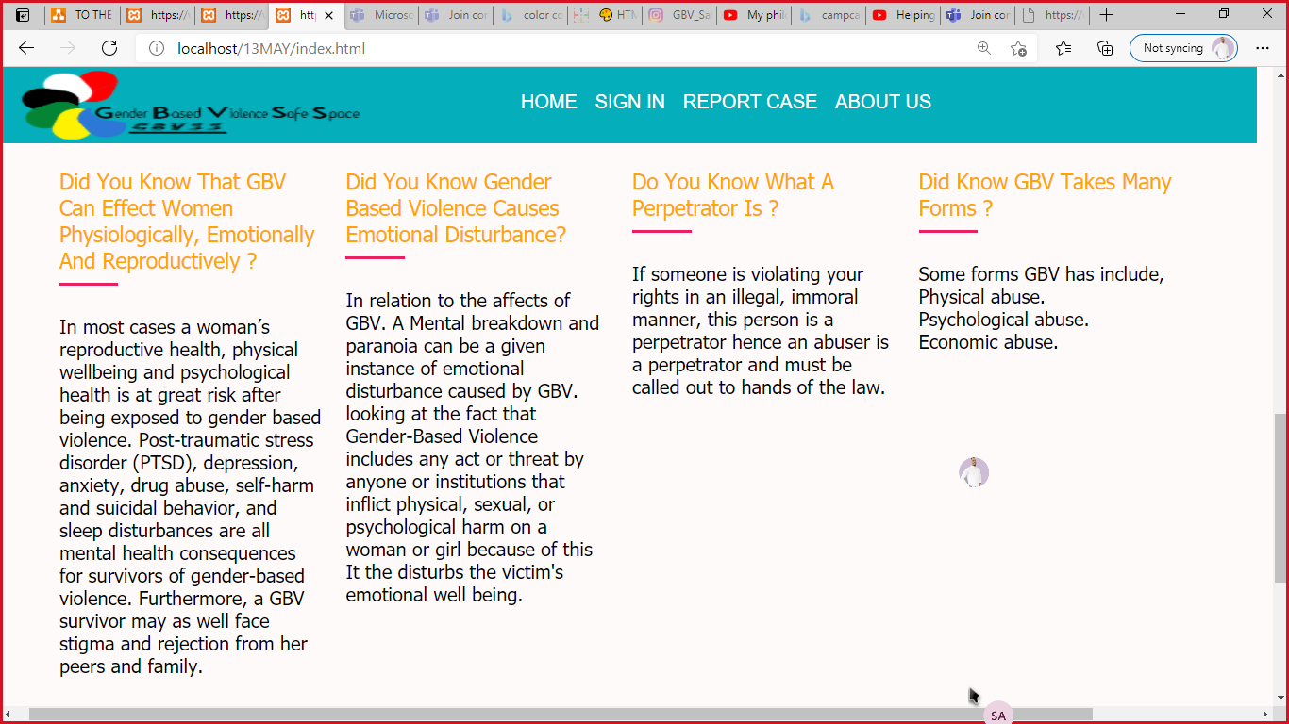 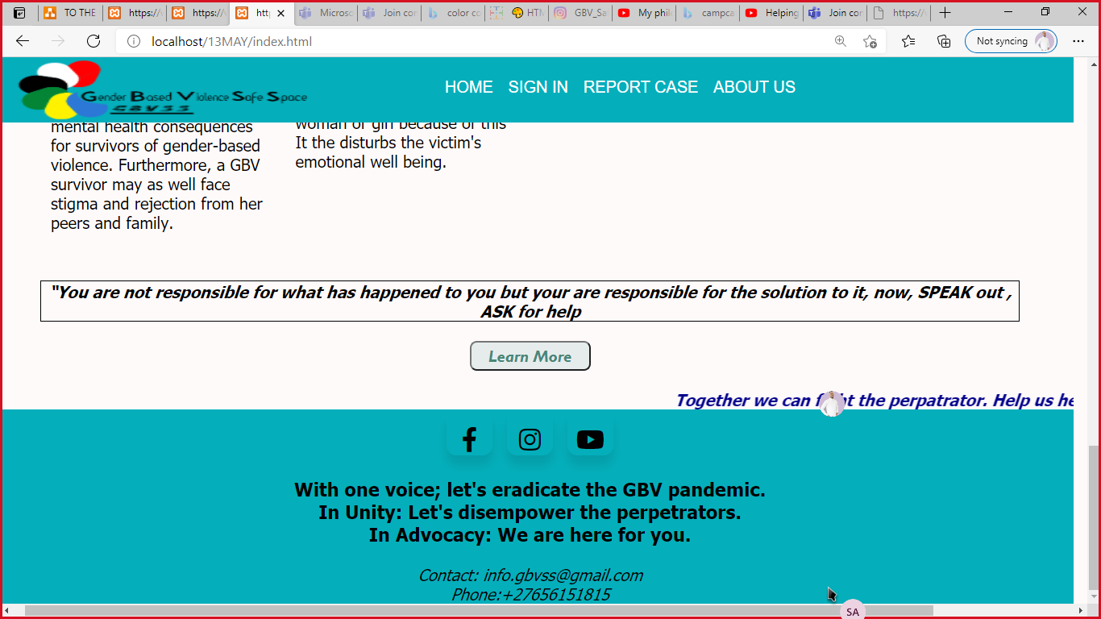

Learn More: Body

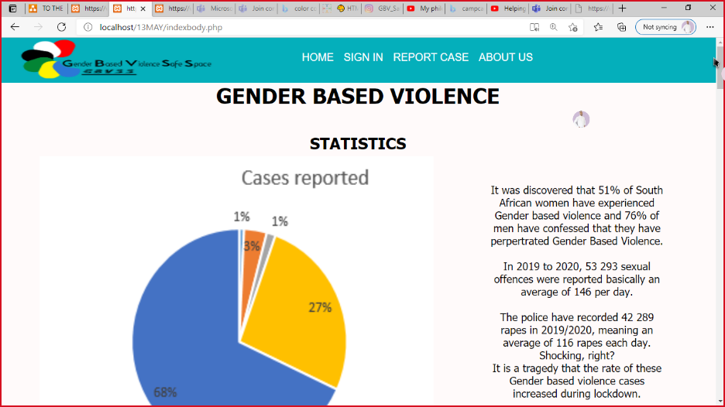 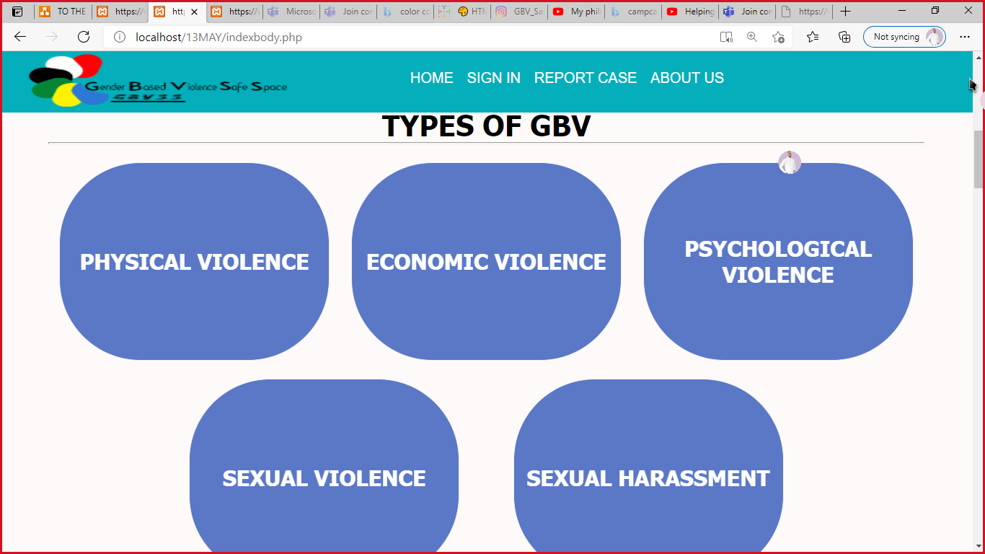

Sign In

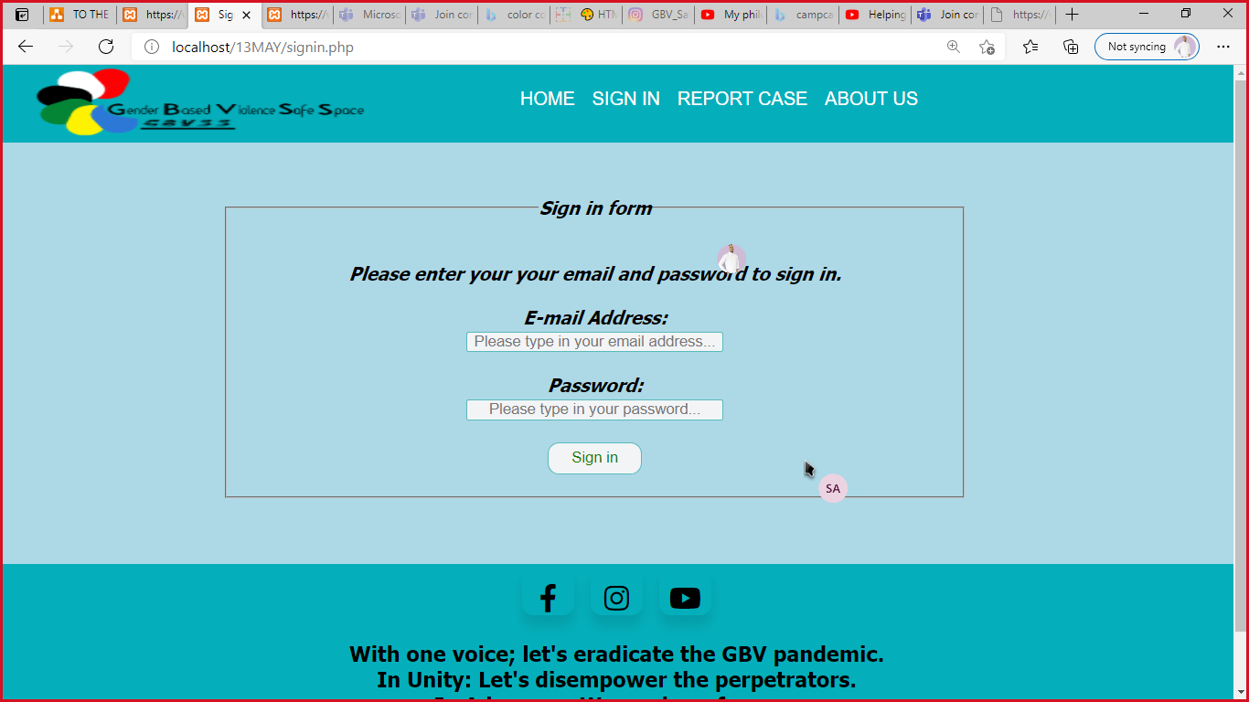 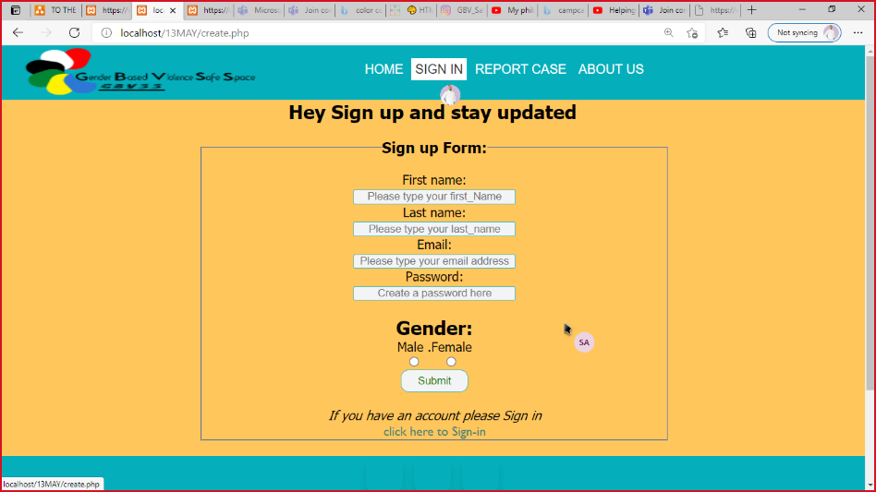

Use Case:

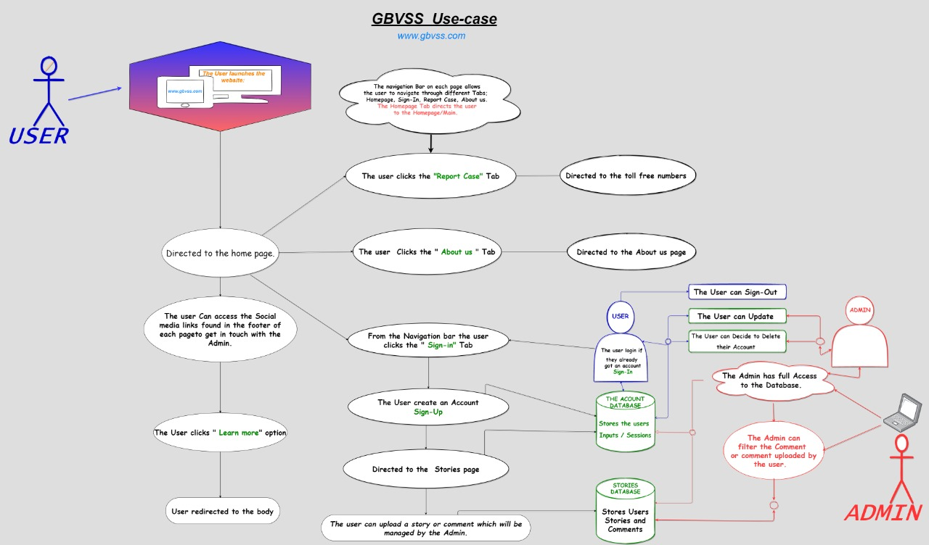

Screen Dumps:

Home Page

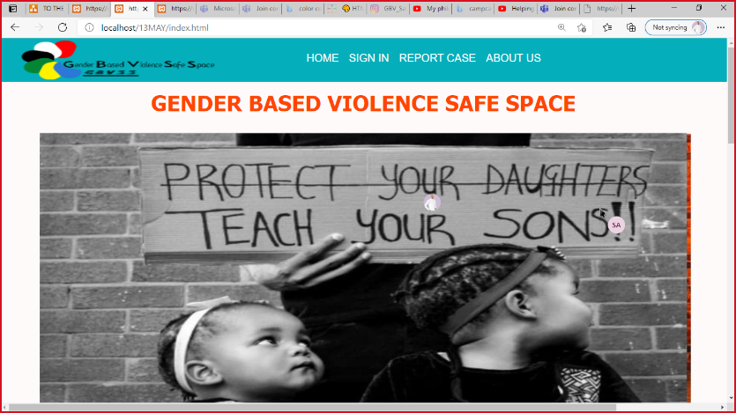 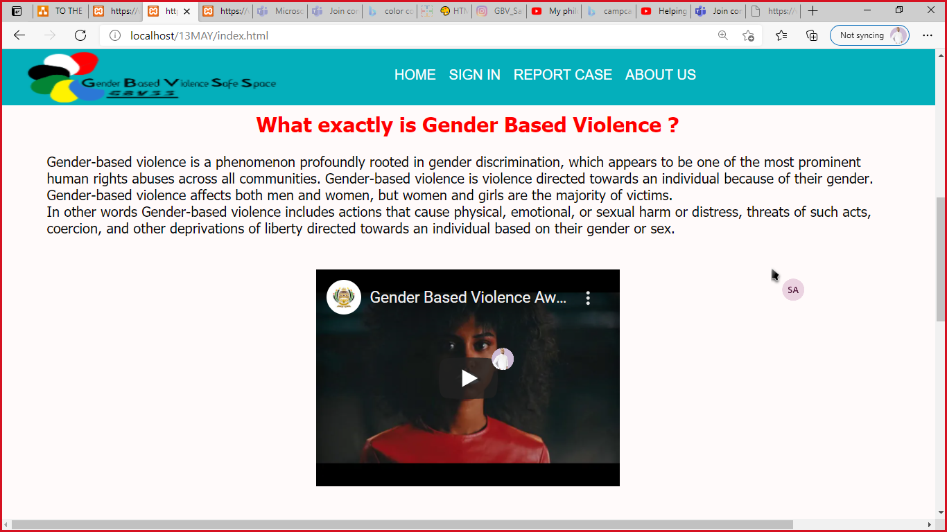

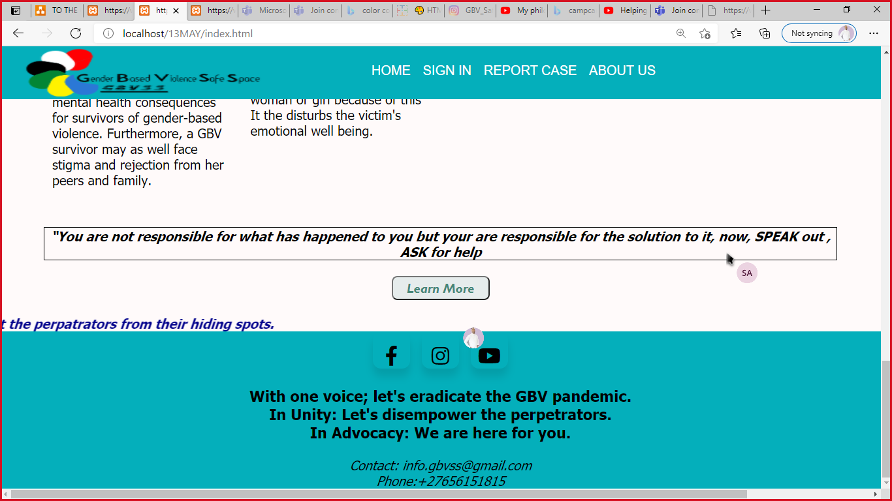

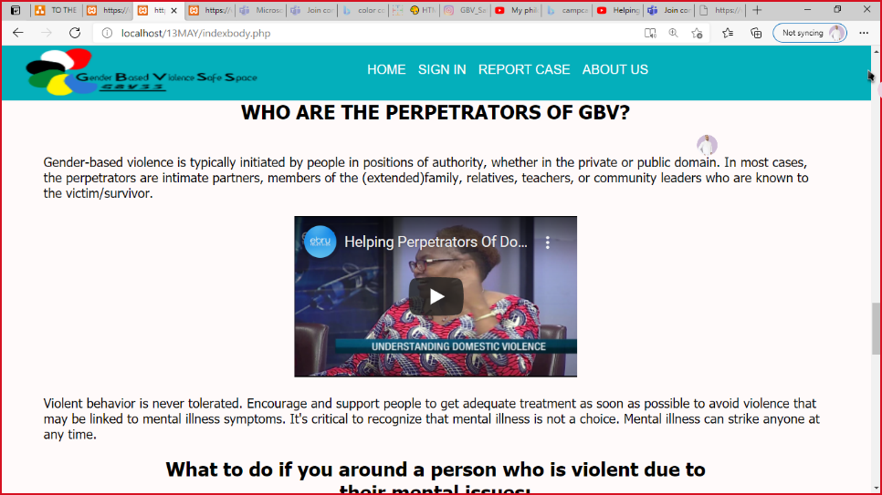 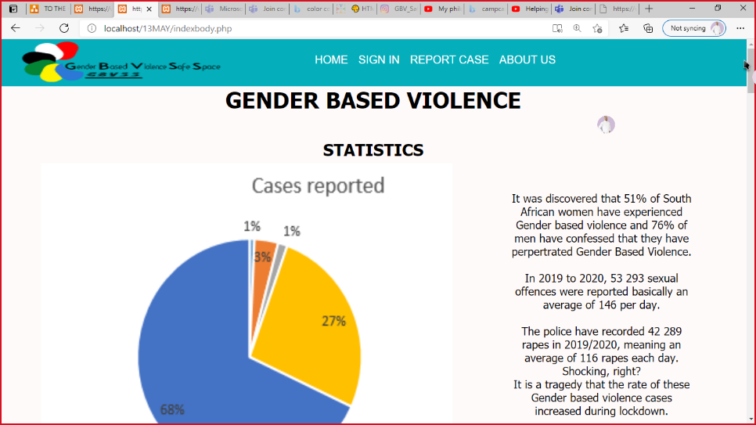

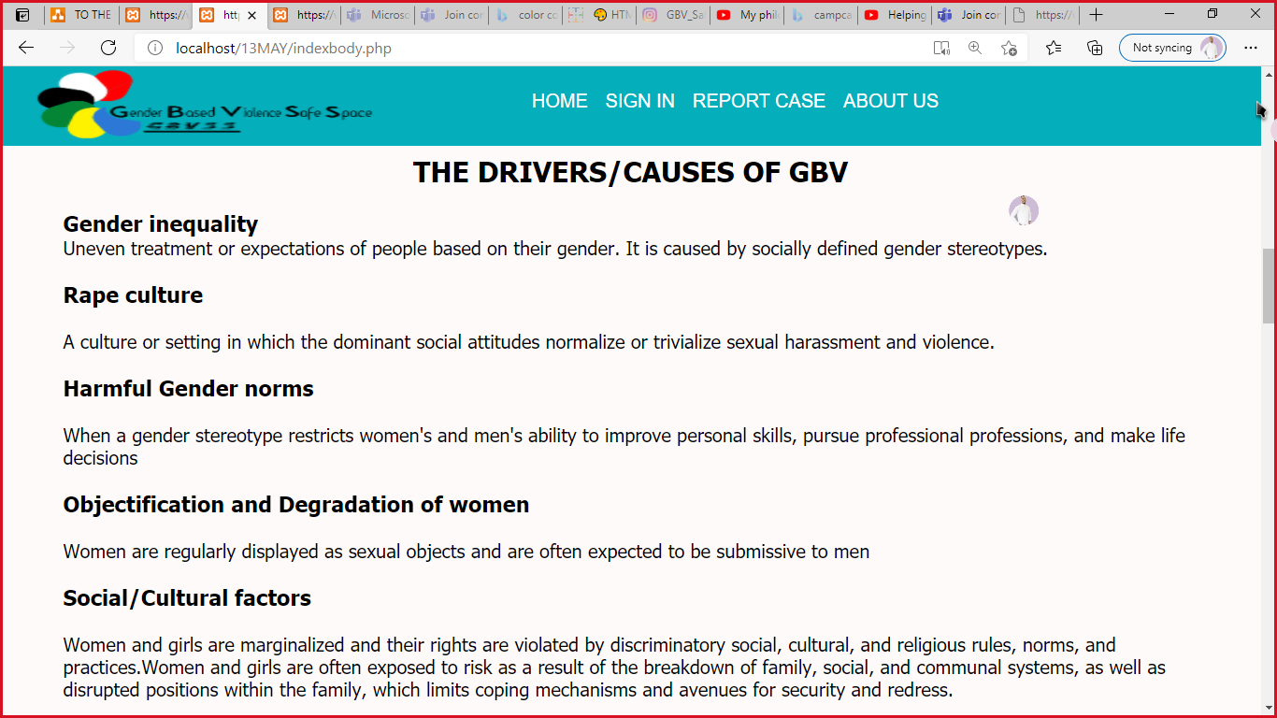 

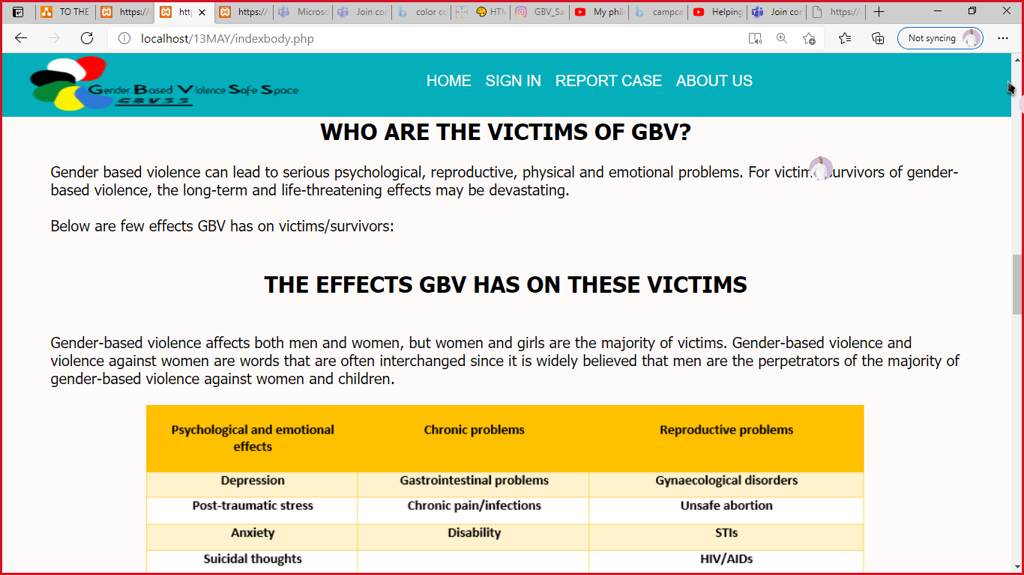 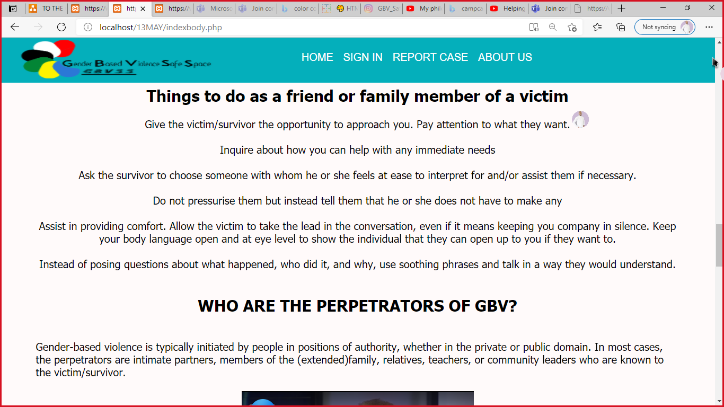

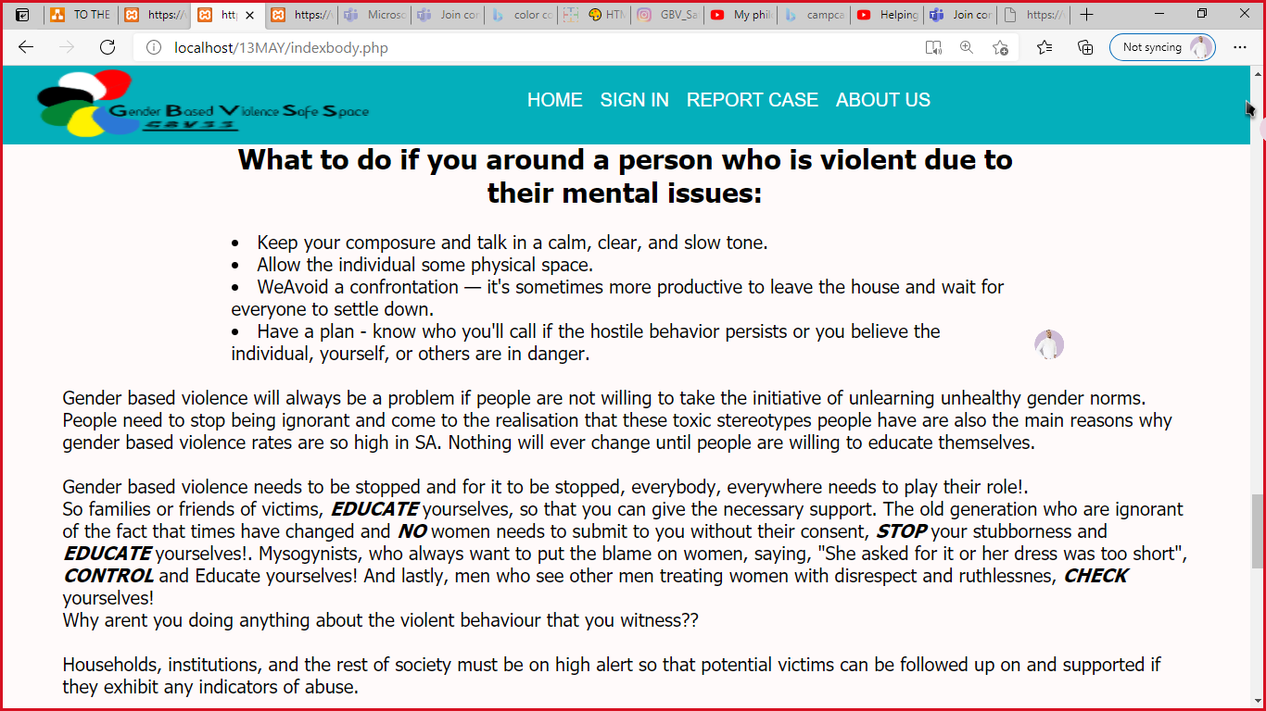 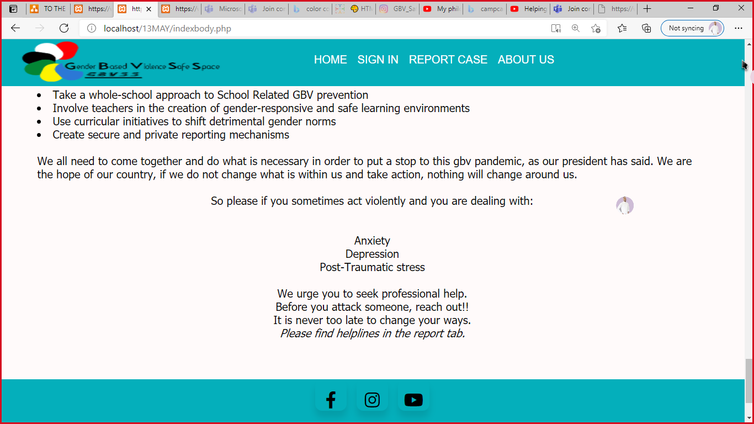

About Us:

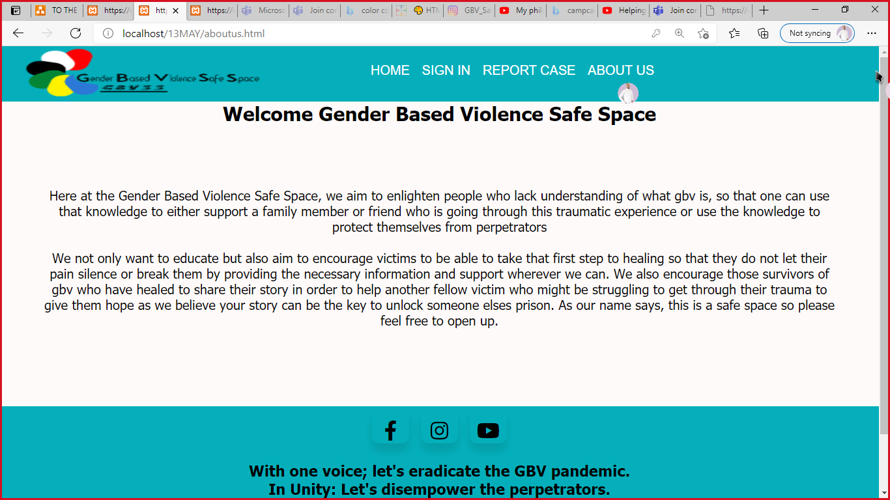

Report Case:

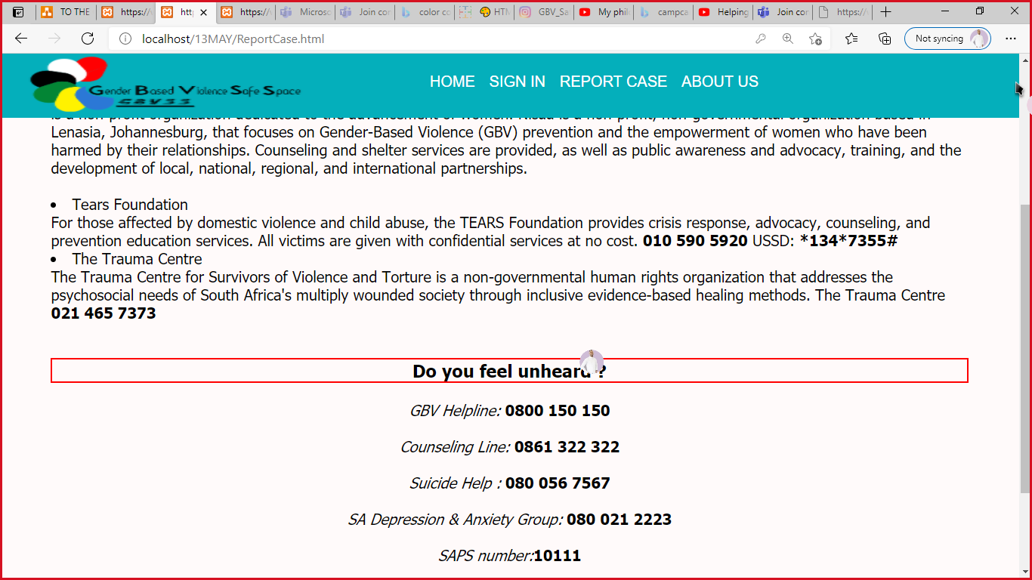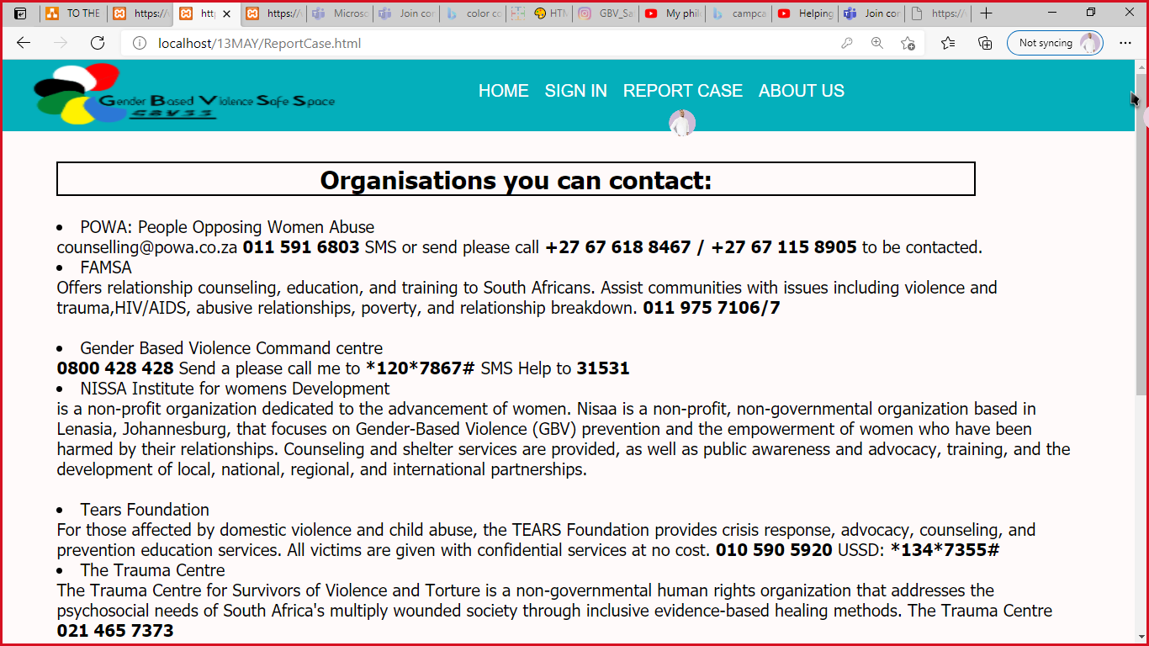

Sign In pages:

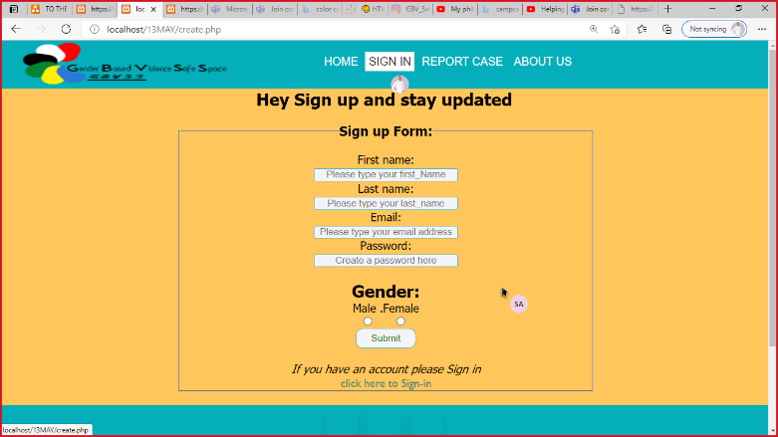 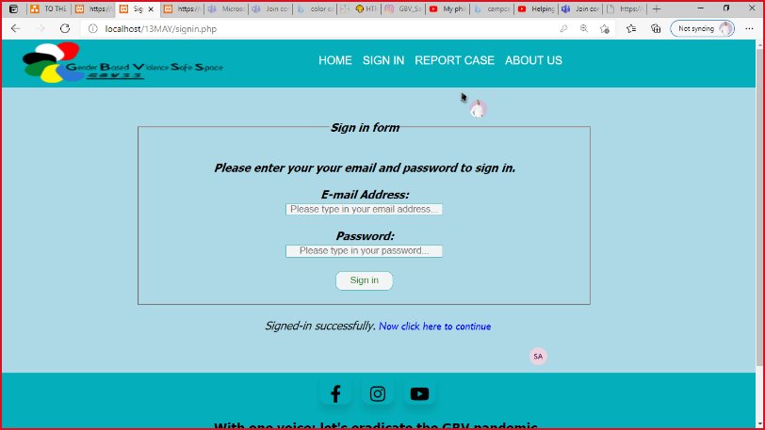

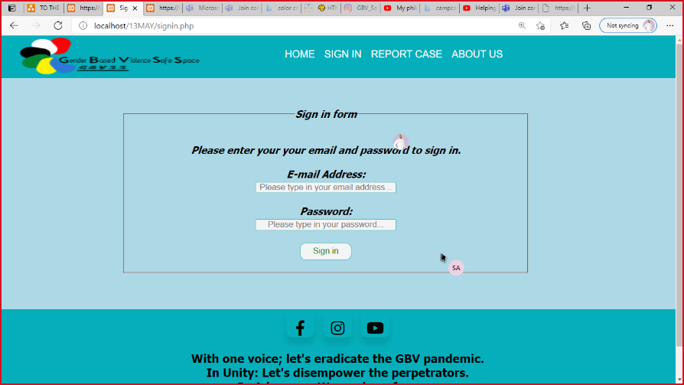

Victims Help page:

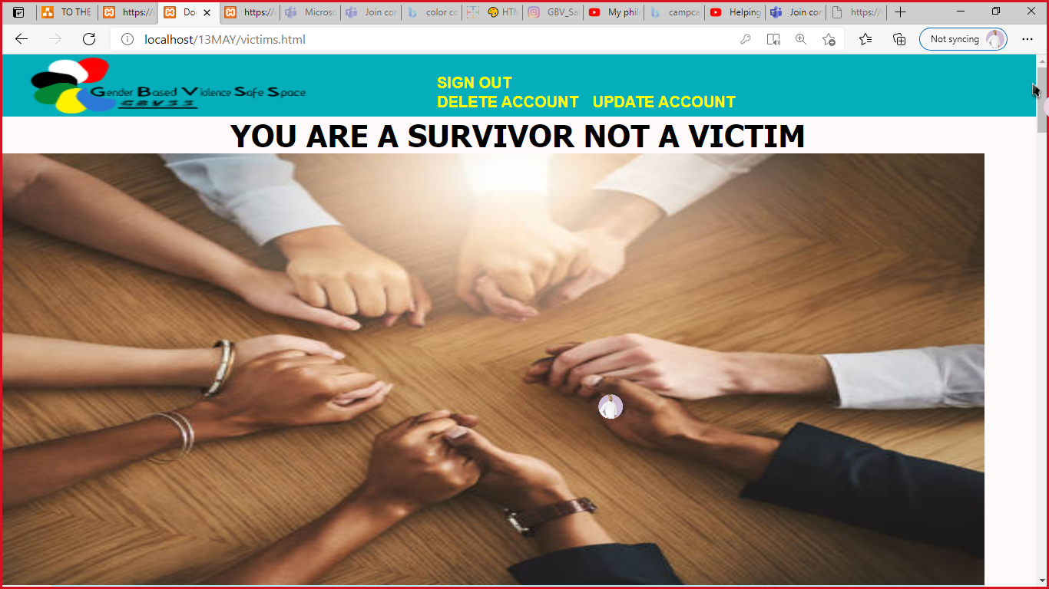 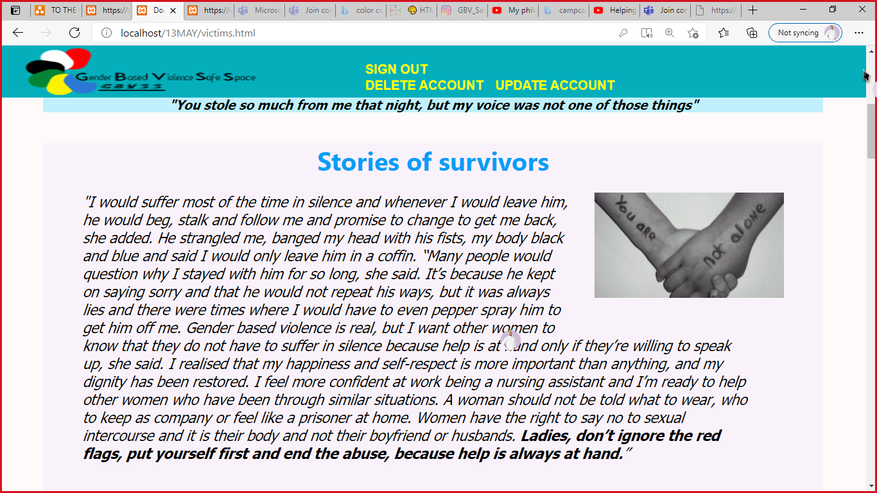

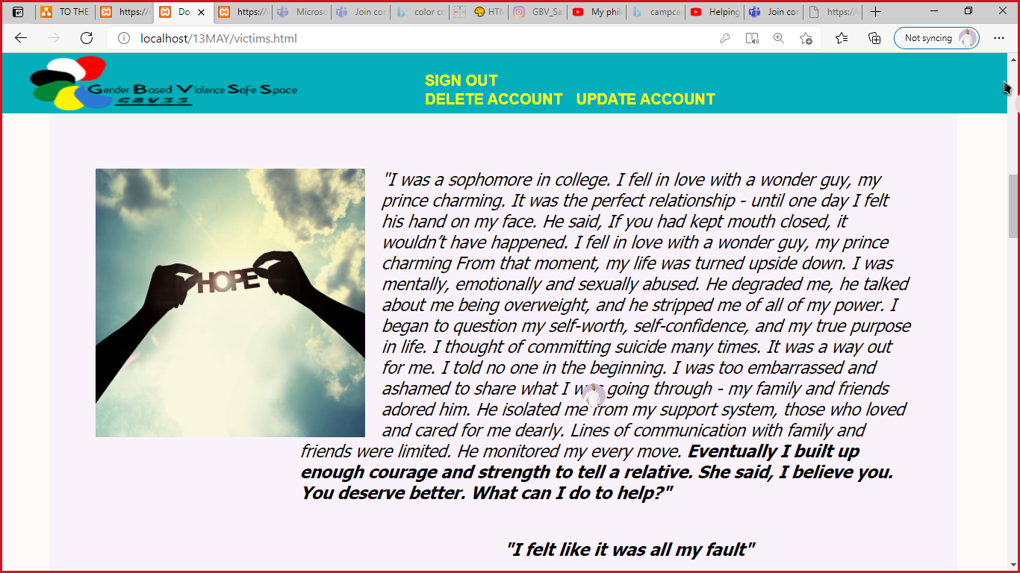 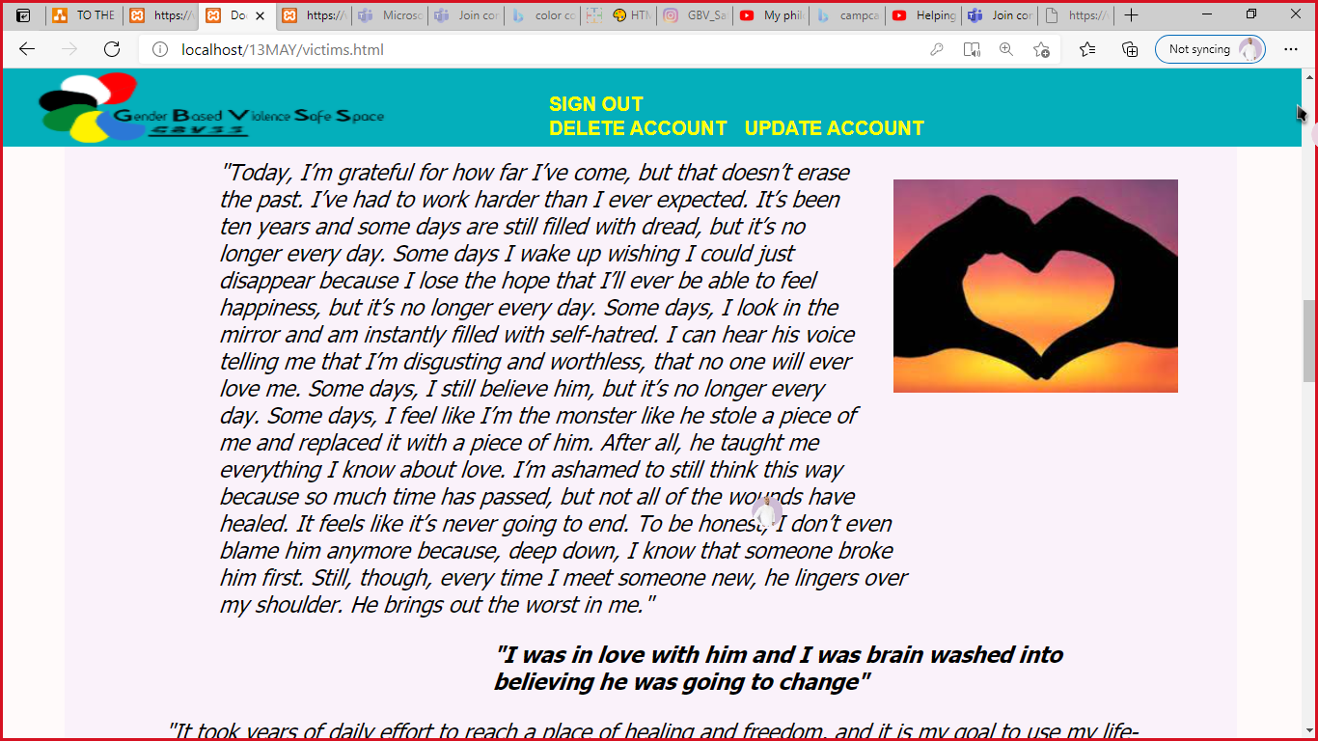

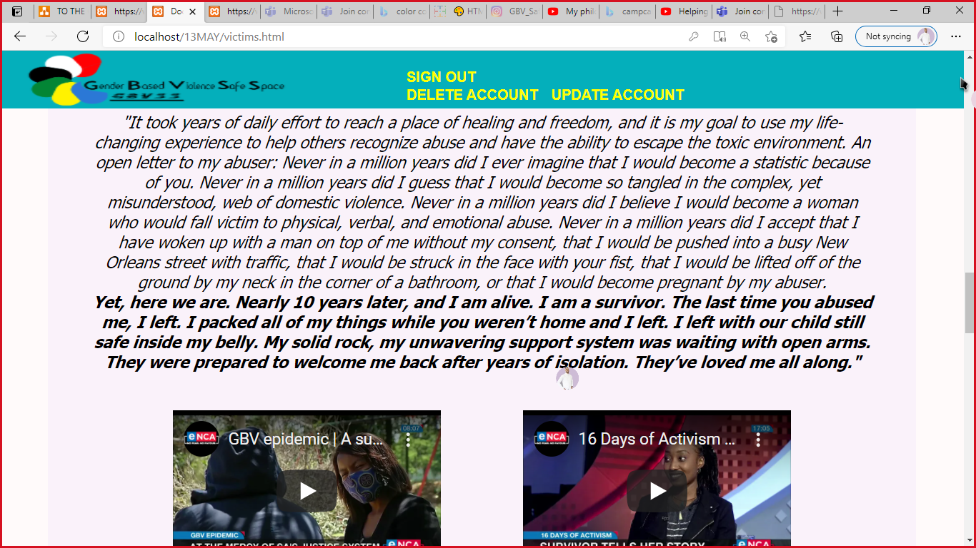 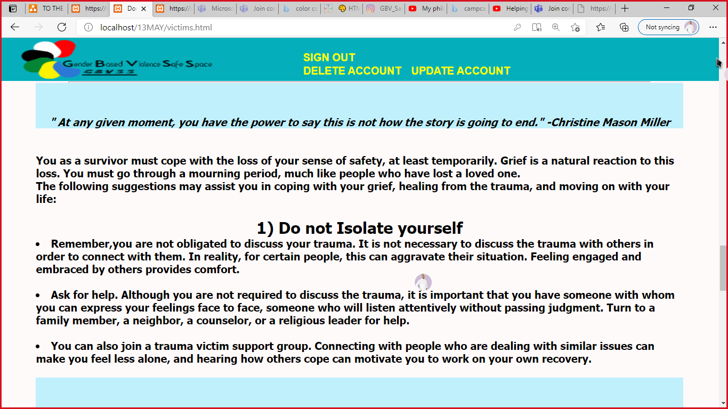

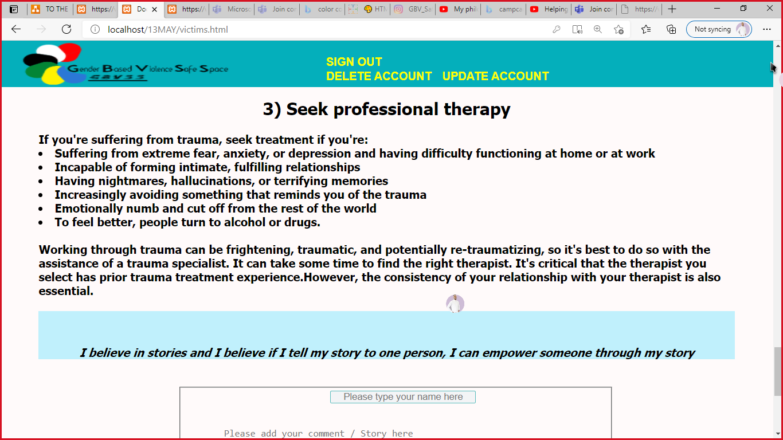 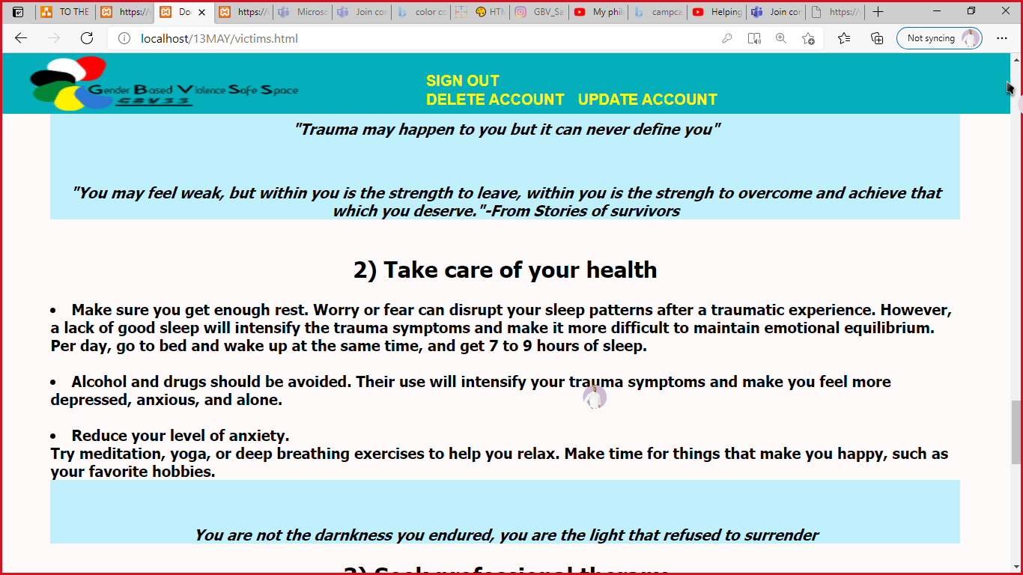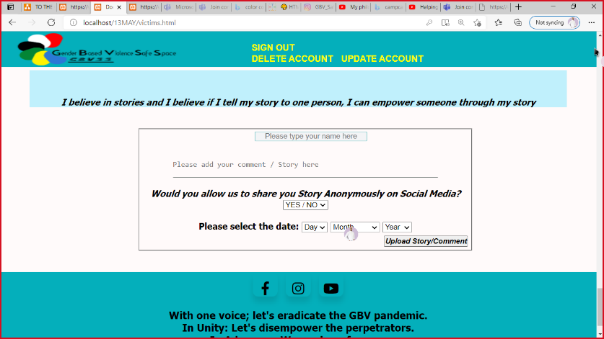

Database:

